Figure 1.Minnesota Department of Natural Resources (MNDNR) Wildlife Management Areas in northwestern Minnesota, USA, with large, impounded wetlands invaded by dense cattail (*Typha angustifolia* and *Typha* x *glauca*) stands. We evaluated the effects of glyphosate herbicide application by the MNDNR to control dense cattail on breeding marshbirds. We conducted standardized marshbird surveys at treatment (red polygons) and control (indicated by survey locations; located in the same or adjacent basin to treatment) sites and compared counts of marshbirds the spring before and up to 3 springs (2105–2018) after herbicide application.

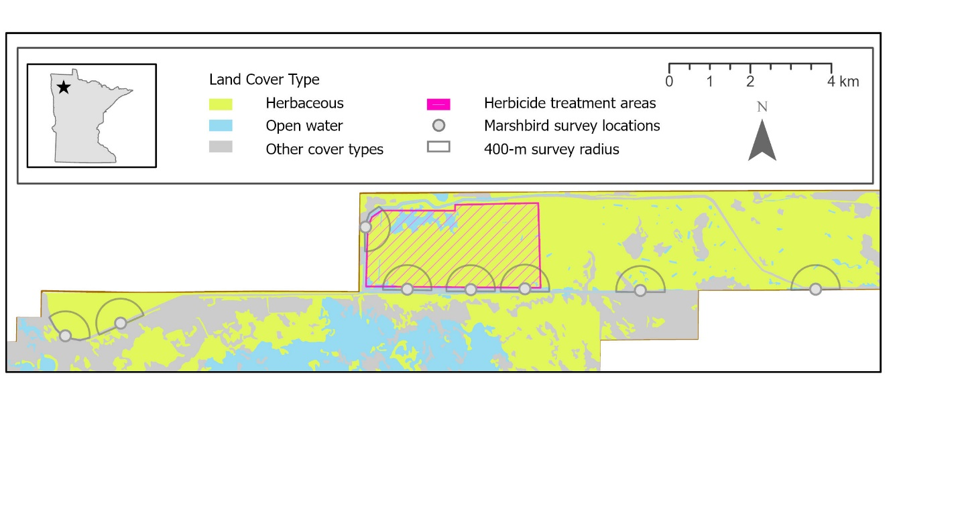

Figure 2.Map of Elm Lake Wildlife Management Area in northwestern Minnesota, USA, indicating cattail (*Typha angustifolia* and *Typha* x *glauca*) treatment areas that received aerial glyphosate herbicide application in late summer and early autumn 2015, and marshbird survey point locations.

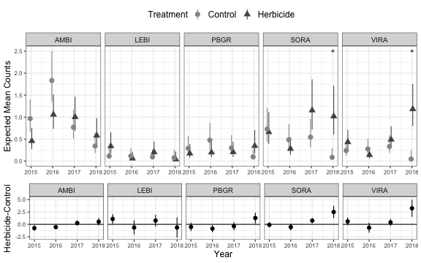

Figure 3.Expected mean marshbird counts (error bars represent 90% confidence interval) within years 2015 to 2018 in treatment and control sites in northwestern Minnesota, USA, and the difference between expected mean marshbird counts for 5 species of marshbirds [American bittern (AMBI), least bittern (LEBI), pied-billed grebe (PBGR), sora (SORA), and Virginia rail (VIRA)]. We evaluated whether herbicide application affected mean marshbird counts by conducting surveys during spring breeding seasons at paired treatment and control sites and evaluated change in number of detections from the spring before to 3 springs after herbicide application (2015 – 2018). Statistical results are pairwise comparisons between the mean expected counts in the control site and the herbicide sites based on a generalized linear mixed model with plot as a random effect and a treatment-by-year interaction that was run for each individual species (log link, Poisson family). Asterisks represent significant treatment effects at p < 0.10.